Data Science Project Protocol

Toronto Hair Salon No-Show and Late cancellation analysis

Author: Eric Abitbol

Introduction

The goal of project is to build a model to predict a no-show or a late cancellation scenario on a future appointment in a hairdresser’s salon.
Before delving into the specific scenario of a Toronto hair salon for which Kaggle provided a dataset, here a few facts on no-shows that can help us to understand the far-reaching impact of missed appointments on service-based businesses or health care systems.
At first in which situations can occur a no-show?
- A person does not show up on a meeting he was supposed to attend (e.g. doctor) without giving any prior notice or
- A spectator does not attend a sport event or any other public event for which he booked a ticket.
- A passenger does not show up for a flight for which he booked a seat.
- A hotel guest booked a room and does not turn up without informing the hotel
Late cancellations (or even “last minute” cancellation) are also a challenge faced by businesses and that can impact as badly as no-shows (e.g. the hotel industry).
No shows and late cancellations generate a loss of productivity/effective time allocation and of revenues. They in addition hurt the rest of your customer base by increasing waiting times for getting an appointment or a service.
In order to understand the magnitude and the importance of this area of study, we’ll discuss quickly no-show impact on health care systems where it is a critical issue.
- Medical appointment no-shows are a plague in the public health care field. As shown in a BMC health service system study , they may represent up to 18% of all the appointments. Each missed appointment cost in 2008 the US health care system $200. Last studies indicate an increase in no-show rates and in missed appointment cost
- Therefore, reducing the rate of no-shows is a top priority around the world. Various strategies have been conducted in order to determine the ways to reduce no shows such as call reminders, behavioral engagement strategies (e.g. contingency management), reducing waiting time (e.g. double-booked appointments, centralized appointment scheduling, etc..) increasing capacity (adding appointment slots), improving environment, etc.
Various studies on no-show in the medicine appointments found that “the most important indicators of future patient no-show behavior were past appointment history, appointment lead time, and multiple appointments on the same day” .
We are in presence of a classification problem and will use logistic regression as well as random forest, Adaboost and XGboost algorithms to predict no-shows or late cancellations. We’ll define late cancellations as cancellations done on the appointment day itself or on the business day preceding the appointment day.
Note the Toronto hair salon dataset information such as multi-appointments in the same day and the previous customers’ expenses over a few months. However, it does not provide the appointment lead time and has a limited history enabling only to log partially the no-show track record of a patient. It does not include demographics information such as gender, age or customer loyalty.
N.B: We will not deal in this project with the recommendations and methods to decrease the no-show ratio and test their actual impact (double booking, adding appointment slots, reminder calls, etc..).

Methodology (Project design)

Data Sources
6 CSV files were downloaded from the hair salon kagle dataset
- Client Cancellations0
- Future Bookings (All Clients)0
- No-Show Report0
- Product Listing (Retail)0
- Receipt Transactions0
- Service Listing0

These files were uploaded into 6 tables the sqlite database hairsalon.db
- cancellation – canceled bookings includes
- futurebooking - 2 types of bookings appear in this least
  - bookings that turned into a real appointment or bookings resulting in a noshow
  - Each appointment is booked for a specific service
- noshow – (noshow booking appear in table futurebooking)
- product – list of retail products sold directly in the hair salon (shampoo, lotions, etc..)
- receipt – a receipt is issue per customer per date for several services and/or products
- service – list of services

Here are he number of rows for the main tables
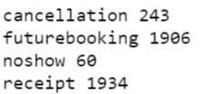
Receipt table description:
For a visit to the hair salon, a bill is issued to a customer with a receipt id. Each visit is associated with one or more contiguous appointments. Each appointment is associated with a service (hiar cut, blow dry, etc..). At least one record is issued for each different service or product sold during the visit. All these billed records are grouped under the same receipt id correpsonding to a visit.
The following table counts receipts having the same number of sub-receipts. 70% of receipts include one or two sub-receipts.
Receipts span from 2018-03-15 to 2018-07-29
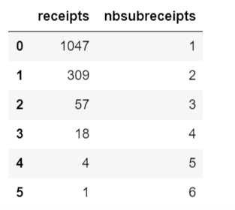

Cancellations

For each cancellation we have calculated the number of business days between the cancellation date and the booking date. We used a python package called workdays.

Cancellations can be divided into 3 categories
- early cancellations occurring at least two business days before the appointnent day
- late cancellations occuring just before the appointments
  - eve cancellation – occuring one business day before the appointment day
  - noshows: cancellations occurring on the appointment day itself

NB: In the graph below it can be observed that more than half of the cancellations are last cancellations.
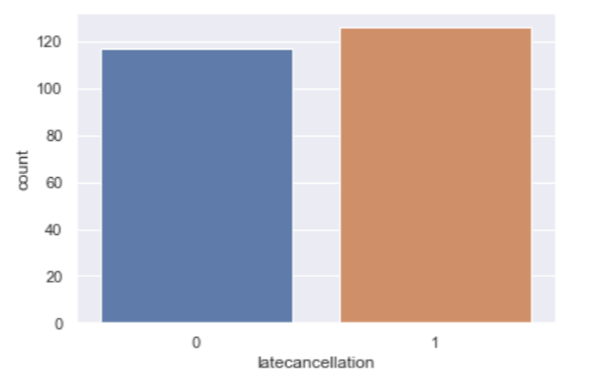

Statistics -

59 noshows out of 1716
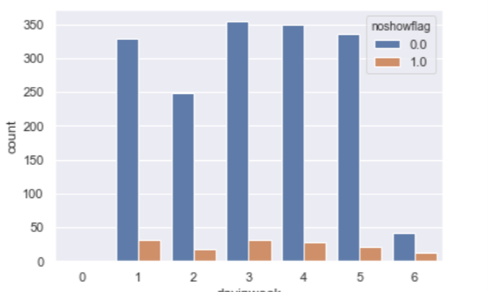

Statisitics

All customers
There are 800 distinct customers.

1799 appointments including no-shows
  - average number of appointments per day on the 3 last months of the sampled period 20
  - average number of appointments per day per customer 1.16
  - 144 noshows and same day cancellations ~ 8%
    - 60 real noshows
    - 84 same day cancellations

The distribution of number of appointments per day over the entire period (including last day cancellations and no shows) shows that the hiar salon reaches its full activity starting from May.

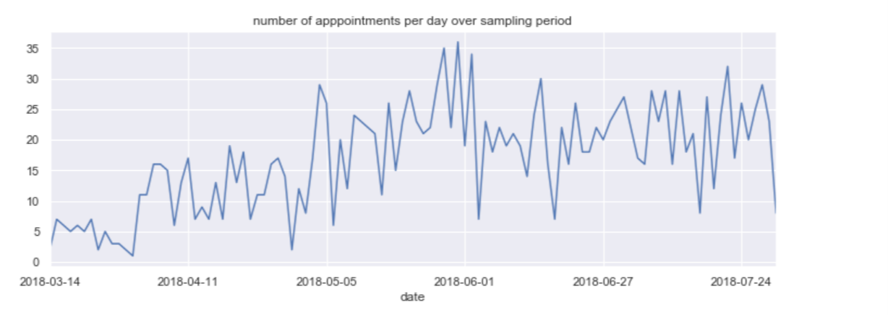
The distribution of number of noshows per day over the entire period (including same day cancellations)

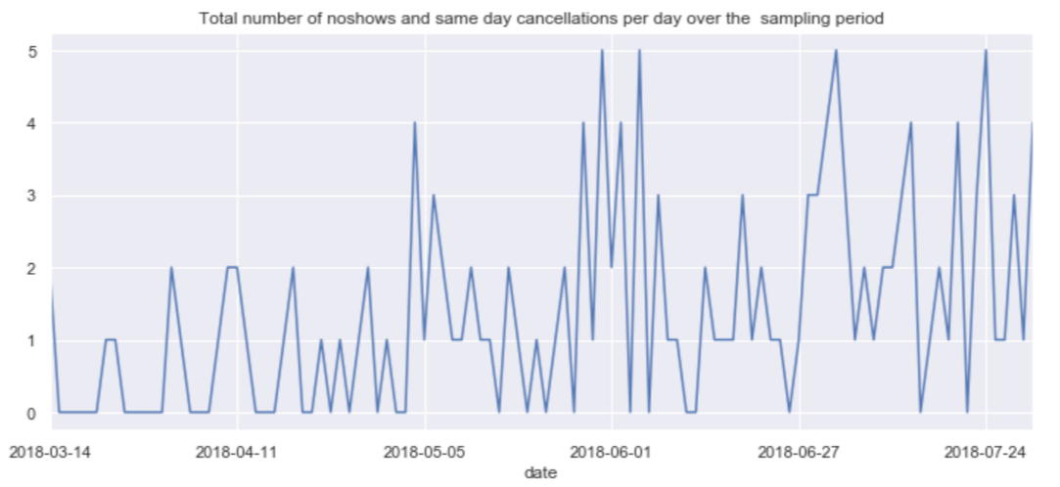

The average number of appointments per day per month is the following.

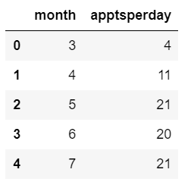

We can see that the hair salon activity is growing over the sampled period. It is confirmed by the fact that the staff is growing over the sampled period [as can be seen in the ilustration 1 in the annex.

One time customers

There are 458 one time customers (they set one/several appointments on one day only during the entire period)

- 520 appointments were recorded for these one time customers
  - average number of appointments per day per customer 1.14
  - 35 noshows and same day cancellations ~ 6.5%
    - 19 real noshows
    - 16 same day cancellations

Recurring customers

There are 342 recurring customers (they set appointments on more than one day)
- 1279 appointments were recorded for these one time customers
  - Average number of appointments per day per customer 1.17
  - 109 noshows and same day cancellations appointments ~ 8.6%
    - 65 real noshow appointments
    - 44 same day cancellations
  - Average number of effective visits per customer over the period 2.97
  - Average time between 2 effective visits - 32 calendar days
  - Average number of noshow visits per customer over the period 0.3 (see illustration in annex 3)
    - Recurring customers with one noshow = 17.5%.
    - Recurring customers with more than one noshow = 5%. For these customers there is an average of 32 days between two noshows

The distribution of the number of days between consecutive effective visits for recurring customers.

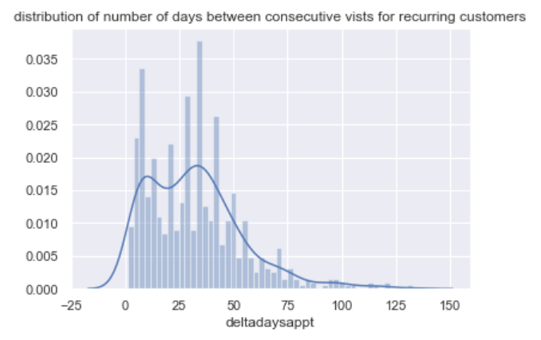

The distribution of the number of days since the last noshow for recurring customers.

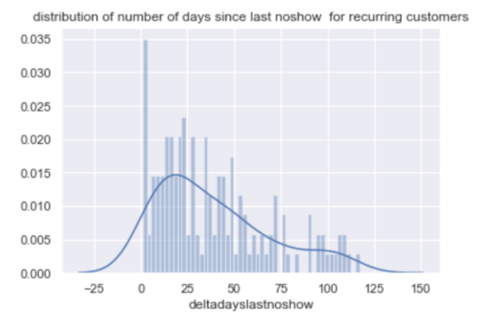

Obvious Anomalies:

*Future booking table
- During all the period, a single appointment was taken on Monday during all the period. Generally hair salons are closed. It is obviously an anomaly. Salon was probably open for a VIP customer (e.g. bride). It will be removed from our dataset.

- An appointment has its client code null which prevents from linking it to the table noshow or cancellation and determining there was a noshow.

*Receipt tables
- Some receipts were issued for a “WALK-IN” CUSTOMER. It is not relevant for our study of forecasting no-shows for booked appointments. We will remove them. Anyway these WALK-IN customers do not appear in the table of booked appointments since they do not book appointments..

Here you have to describe how do you plan to manipulate the data. For this you have to answer to the following questions:
- Which data will be used?
  - Describe data sources
  - Describe possible external data sources that may enrich our data
  - Data for external validation?
- On which time frames periods will your project will be based on?
  - Time-frame for training
  - Time-frame for test?
- How do you define your subjects?
  - Inclusion criteria?
  - Exclusion criteria?
- Which would be your outcome variable?
- Are there confounder variables that may affect the outcome?
- Is there a possible source of bias in our data?
- Describe your data exploration strategy.
- Which techniques will be applied to enrich the data?
- How you will deal with outliers?
- How you will deal with missing values
- Add at the end of the protocol (appendix) the Data retrieval protocol

Outliers
Field day in week: There is only one appointment on Monday which is day where generally hair salon are closed. This is an exception. We can drop this record. [it must be a one time exception]

Models
Here you have to describe how do you plan to develop your models:
- How do you plan to divide your data
  - Training, validation, test - proportions, techniques
- Do you need to balance your data? How?
- Do you need to stratify/subsample your data? How?
- What techniques will you apply to model your outcome?
  - Unsupervised
  - Regression
  - Classification
- Will you use cross-validation and/or bootstrap?
- Which measures you will use to train and evaluate your models? Why?
- Do you plan to use ensembling or will use your best model?

Deployment of your model
- Who will make the QA of the project?
  - Which units will be assessed
  - Write a QA protocol for each step of the project
- Who is the final user of the predictions?
- How the prediction will be presented to the final user?
- How will the final user be trained to use and interpret the prediction?
- On which platform the predictions will be deployed?
- How frequently the model will be updated?
- What will happen in cases where the model return a null prediction (eg. incomplete data)?
- Which models were used and which were selected for the final prediction.
- Which measurements were used to evaluate the prediction.
- Which results we got from those models.

Results
Here you will present the main results of all the process. We will describe:
- The final amount of data used (total, train, test, etc)
- The amount of outliers and the way of treating them,
- The amount of missing values and the methods used for imputing them,
- The distribution of the data (timeframes)
- The methods used to transform the data and to generate new features.

Conclusion
Here you will write about how the project began, which were the most important challenges you had when developing the project, and how did you get the final prediction. You have to discuss also the limitations of the model, when it can be used and when not.

Annex

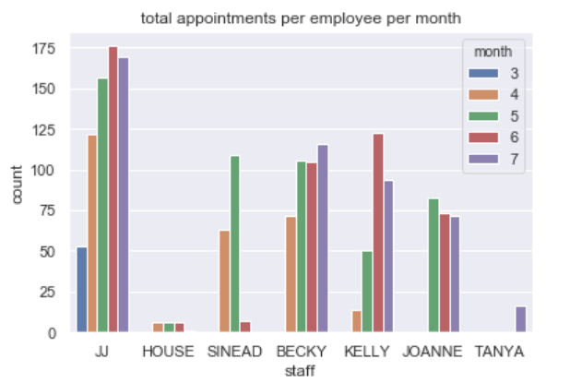Illustration 1: Number of employees growing over period
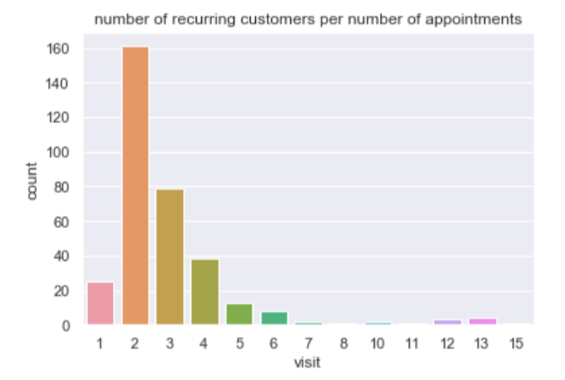Illustration 2: dist. of number of recurring customers over number of distinct visits

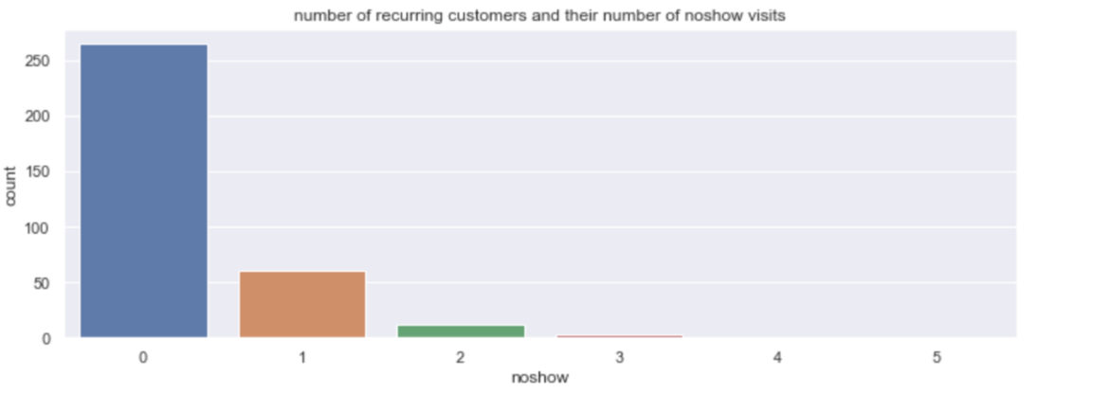Illustration 3: distribution recurring customers over number of noshows

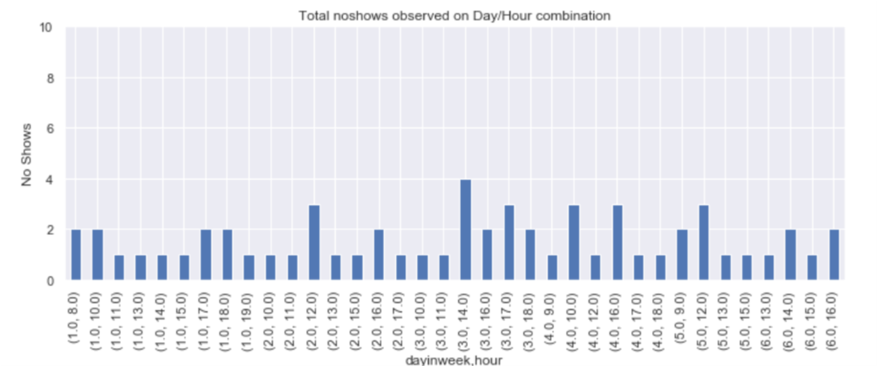

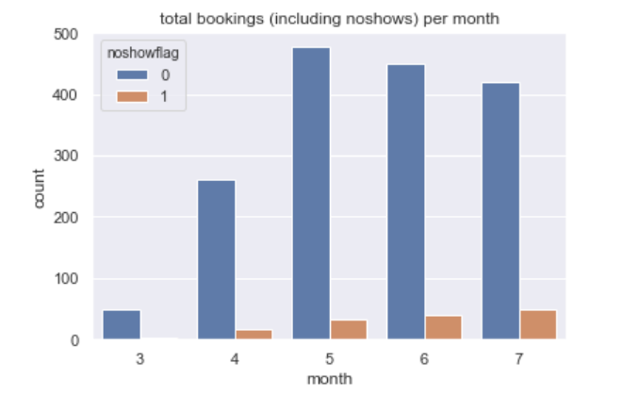
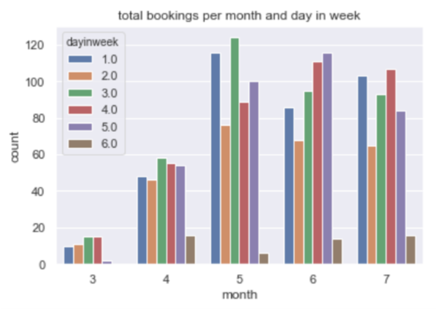

US National library of Medicine https://www.ncbi.nlm.nih.gov/pmc/articles/PMC4714455/
US National library of Medicine https://www.ncbi.nlm.nih.gov/pmc/articles/PMC3962267/
Military Medicine Vol 182 May/June 2017
https://www.kaggle.com/frederickferguson/hair-salon-no-show-data-set

